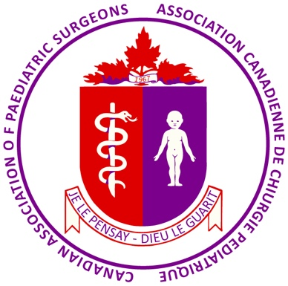
CAPS National Undergraduate Learning Objectives for Students of Canadian Medical Schools

The following represents what the Canadian Association of Paediatric Surgeons (CAPS) believes are the necessary and reasonable Learning Objectives for all medical students to achieve by the time of their graduation as pertaining to the surgical problems of infants, children and youth:

Pediatric Surgical Clinical Considerations:

Bear in mind the following when gathering histories, doing physical examinations and undertaking investigations in babies and children with potential surgical problems.
- History: Most often the history is obtained from the parent(s) / responsible caregiver but even young children can and should be addressed in history-gathering as well. Also explore the psycho-social context of the child and family as it can be of critical importance in the care of both.
- Physical examination: Children often can be fearful of doctors (and the parents may show their fear as well). Respect the child and use a gentle approach, assuaging their fears through distractions, games, and gaining their trust through friendliness. Never be dishonest (e.g. telling the child, “this isn’t going to hurt” when you’re about to do something that you know will be uncomfortable for the youngster). Take it slow and involve a parent in the examination process. Be appropriately thorough and do not neglect to do what’s necessary (e.g. DREs when indicated).
- Investigations: Ask only for tests which will be truly helpful and avoid testing where results will give little guidance (e.g. CRP in abdominal pain). Understand the operational characteristics of any test you plan to do (e.g. potential harm from false positive/negative result). Consider the potential harmful effect of the test (e.g. CT scanning and radiation exposure to a child increasing future risks of malignancy). Ensure that requested tests will be done properly (e.g. AXR alone is only a supine view and of little use if considering a bowel obstruction; a supine and upright film will give far more information).
- Physiology & Anatomy: Babies and children, because of their particular stage of growth and development often manifest and react to disease in ways very different than the adult. Remember, “Children are not just small adults.”

Specific Learning Objectives:
Given a patient with a typical history, signs and investigation results who has any disease/injury on the following list, the student will be able to:
  - Identify the disease/injury as the most likely diagnosis;
  - Appropriately include other less likely, but still possible diagnoses in the differential diagnosis and justify their inclusion using knowledge about their presenting features (not expected to be comprehensive)
  - Explain to the patient/parent the cause (if known), generally how common the disorder is and the typical natural history;
  - Denote potential life/limb/organ-threatening pathology and possible need for timely consultation/referral
  - Discuss with the patient/parent the options and recommendations for management;
  - Provide the patient/parent with a general prognosis;
  - Outline a general management plan (need not include the specifics of surgical or intensive care management)

- Inguino-scrotal/Abdominal wall pathology:
- Testicular torsion
- Inguinal hernia (asymptomatic or symptomatic, including incarcerated)
- Hydroceles
- Cryptorchidism
- Umbilical hernia
- The ‘Acute Abdomen’—specifically the following:
- Intestinal volvulus/malrotation
- Appendicitis (both early and ruptured)
- Intussusception
- Meckel’s Diverticulum
- Bowel obstructions (general diagnosis and management)
- Infantile hypertrophic pyloric stenosis
- Biliary atresia
- Pediatric malignancies:
  - Neuroblastoma
  - Wilms’ tumour
  - Lymphoma
- Acute congenital surgical disease:
  - Esophageal atresia (& potential accompanying VACTERL syndrome elements)
  - Imperforate anus
  - Intestinal atresia
  - Hirschsprung’s disease
  - Congenital diaphragmatic hernia
  - Gastroschisis & Omphalocele

- Pediatric trauma:
- Pediatric Poly-trauma
- Occult trauma & Non-accidental Injury

